|  |  |
| --- | --- |
| Scubbi | Specification Document  Online Diving Portal - Dive Center Admin Console Module  Version 1.0.0 |
|  |  |

# Confidentiality

This document contains proprietary information that is confidential to SCUBBI SDN. BHD. Disclosure of this document in full or in part, may result in material damage to SCUBBI SDN. BHD. Written permission must be obtained from SCUBBI SDN BHD prior to the disclosure of this document to a third party.

|  |  |
| --- | --- |
| Version: | 1.0 |
| Approval State: | Draft |
| File Name: | Scubbi_2017_V1.0.0_FSD_DCAdminModule_v1.0@20170320.docx |
| Confidentiality Category: | For Internal Use Only |

**Document Change Control**

| **Version** | **Date** | **Authors** | **Summary of Changes** |
| --- | --- | --- | --- |
| 1.0 | 14 March 2017 | Raymond Wong | Initial Release |
| 1.1 | 20 March 2017 | Fong Zhan Teng | Added Section 1.11 Become a Partner |
|  |  |  |  |
|  |  |  |  |
|  |  |  |  |

**Document Sign-Off**

|  |  |  |  |
| --- | --- | --- | --- |
| **Version No: 1.0** | | | |
| **Role** | **Name** | **Signature** | **Date** |
| Author | **Raymond Wong** |  | 14 March 2017 |
| Reviewer |  |  |  |
| Reviewer |  |  |  |
| Reviewer |  |  |  |
| Approver |  |  |  |
| Approver |  |  |  |

Table Of Contents

1 Screen Layout and Function Design 5

1.1 Landing Page 5

1.1.1 Business Rules - Common 5

1.2 Dive Center Profile 6

1.2.1 Details Tab 6

1.2.1.1 Business Rules 6

1.2.2 Contacts Tab 7

1.2.2.1 Business Rules 7

1.2.3 Gallery Tab 8

1.2.3.1 Business Rules 8

1.3 Leisure Dive 9

1.3.1 Leisure Dive Dashboard 9

1.3.1.1 Business Rules 9

1.3.2 Add Standard Product 10

1.3.2.1 Business Rules 10

1.3.3 Add Customized Product 11

1.3.3.1 Business Rules 11

1.4 Courses & Specialties 12

1.4.1 Courses & Specialties Dashboard 12

1.4.1.1 Business Rules 12

1.4.2 Add Standard Product 13

1.4.2.1 Business Rules 13

1.4.3 Add Customized Product 14

1.4.3.1 Business Rules 14

1.5 Dive Package 15

1.5.1 Dive Package Dashboard 15

1.5.1.1 Business Rules 15

1.5.2 Add Customized Product 15

1.5.2.1 Business Rules 16

1.6 Guided Tours 18

1.6.1 Guided Tours Dashboard 18

1.6.1.1 Business Rules 18

1.6.2 Add Customized Product 19

1.6.2.1 Business Rules 20

1.7 Booking & Cancellation Policies *Newly Added 21

1.7.1 Booking & Cancellation Dashboard 21

1.7.1.1 Business Rules 21

1.7.1.2 Edit Policy 22

1.7.2 Booking Policy Tab 23

1.7.2.1 Business Rules 23

1.7.2.2 Add Policy 24

1.7.3 Cancellation Policy Tab 25

1.7.3.1 Business Rules 25

1.7.3.2 Add Policy 26

1.8 Reviews *Newly Added 27

1.8.1 Reviews Dashboard 27

1.8.1.1 Business Rules 27

1.9 Messages *Newly Added 28

1.9.1 My Bookings & Calendar Dashboard 28

1.9.1.1 Business Rules 28

1.10 My Bookings & Calendar *Newly Added 29

1.10.1 My Bookings & Calendar Dashboard 29

1.10.1.1 Business Rules 29

1.10.2 My Bookings Tab 30

1.10.2.1 Business Rules 30

1.10.3 Availability Calendar Tab 31

1.10.3.1 Business Rules 31

1.11 Become a Partner *Newly Added 32

1.11.1 Business Rules 32

1.11.2 Business Rules 33

1.11.3 Business Rules 34

2 Appendices 35

***Terms and Definitions***

Abbreviation below will be used throughout the document:

|  |  |
| --- | --- |
| Abbreviation | Description |
| DC Admin | Dive Centre Admin Module |
| SA Admin | Scubbi Admin Module |
| CM | Customer Module |
| FSD | Functional Specification Document |

# Screen Layout and Function Design

## Landing Page

This is the landing page that will show when Dive Center first accessed to SCUBBI website via browsers (Internet Explorer, Google Chrome, and Firefox).

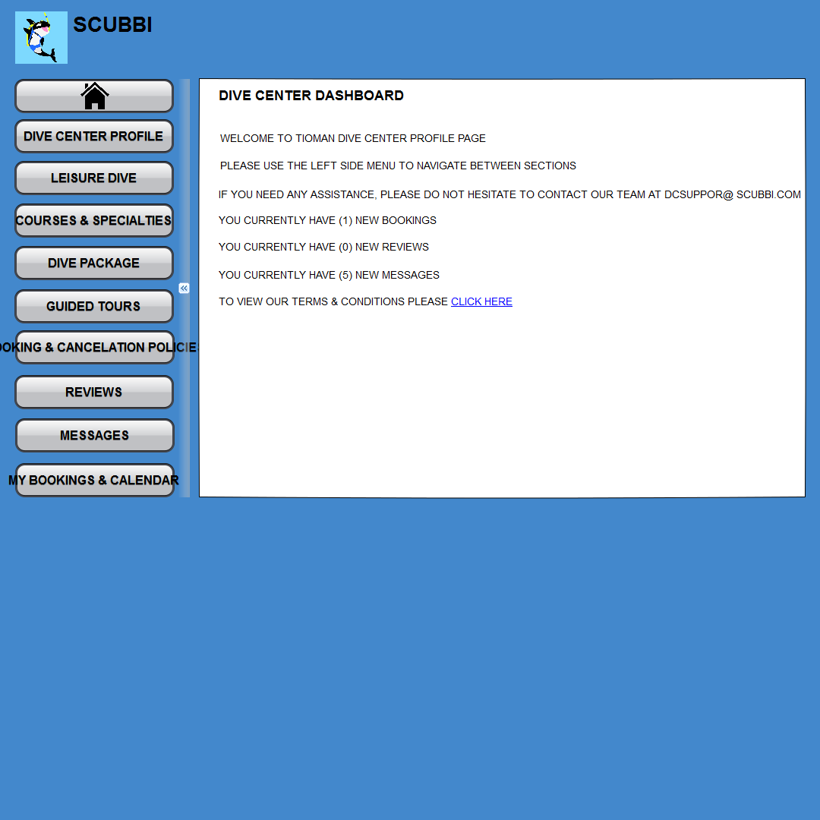

<- Please refer to My Messages Tab for latest UI for Navigation Menu/Tab

**Screenshot 1: Home Page > Dive Center Tab**

### Business Rules - Common

| **S/N** | **Description** |
| --- | --- |
|  | When landing page is load, default to Home Tab and show Navigation Menu on the left and Dashboard Information Screen on the right. |
|  |  |
|  |  |

## Dive Center Profile

### Details Tab

Upon clicking **Landing page** > **Dive Center Profile tab**, this will display the dive center details page. All the Dive centers belong to the selected Country and Island will be display.

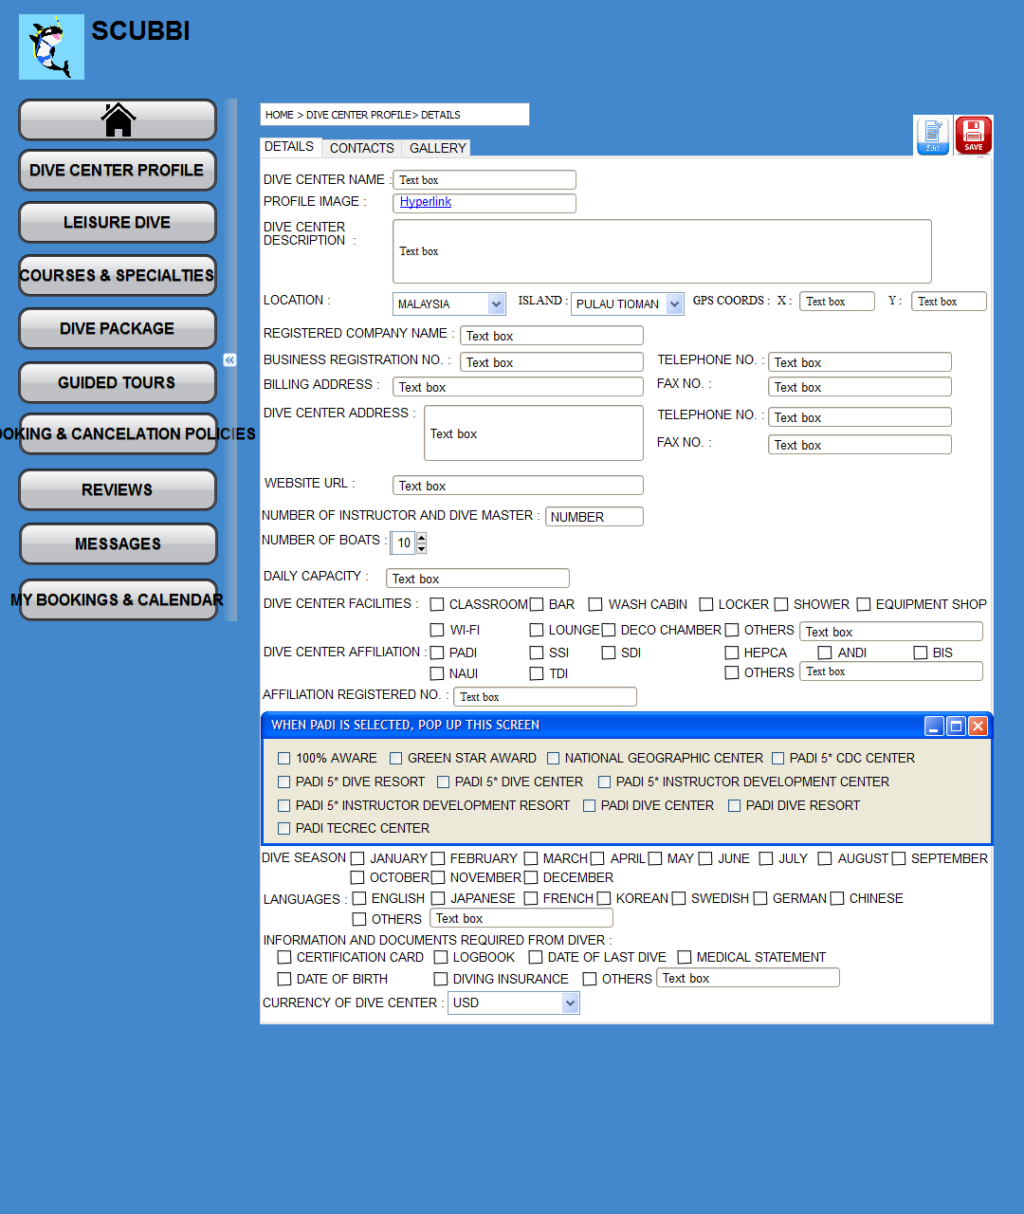

No changes but refined and added rules.

**Screenshot 11: Search Result Page (Before Scroll down)**

#### Business Rules

|  |  |  |  |  |  |
| --- | --- | --- | --- | --- | --- |
| **Field Name** | **Description** | **Data Type** | **Mandatory** | **Format** | **Data Source** |
|  |  |  |  |  |  |
|  |  | | | | |
|  |  |  |  |  |  |

### Contacts Tab

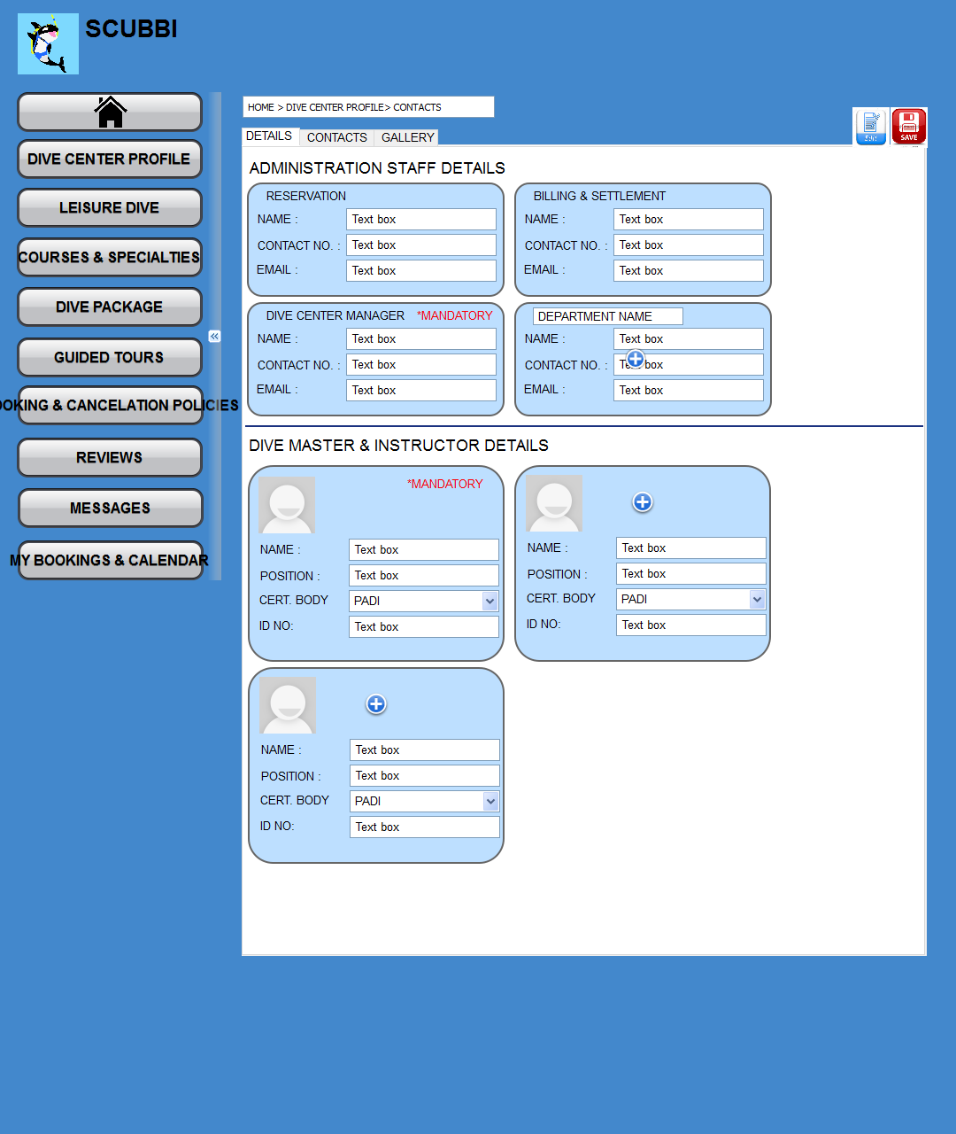

#### Business Rules

|  |  |  |  |  |  |
| --- | --- | --- | --- | --- | --- |
| **Field Name** | **Description** | **Data Type** | **Mandatory** | **Format** | **Data Source** |
|  |  |  |  |  |  |
|  |  | | | | |
|  |  |  |  |  |  |
|  |  | | | | |
|  |  |  |  |  |  |
|  |  | | | | |
|  |  |  |  |  |  |
|  |  | | | | |

### Gallery Tab

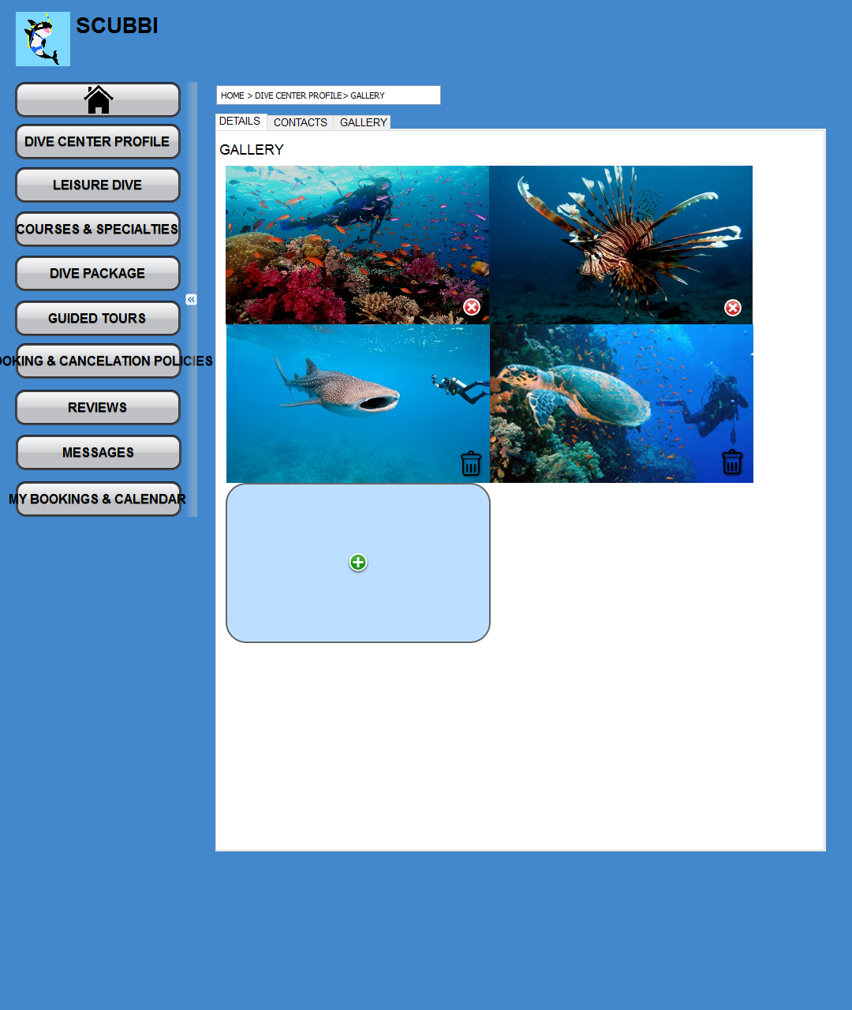

#### Business Rules

|  |  |  |  |  |  |
| --- | --- | --- | --- | --- | --- |
| **Field Name** | **Description** | **Data Type** | **Mandatory** | **Format** | **Data Source** |
|  |  |  |  |  |  |
|  |  | | | | |
|  |  |  |  |  |  |

## Leisure Dive

### Leisure Dive Dashboard

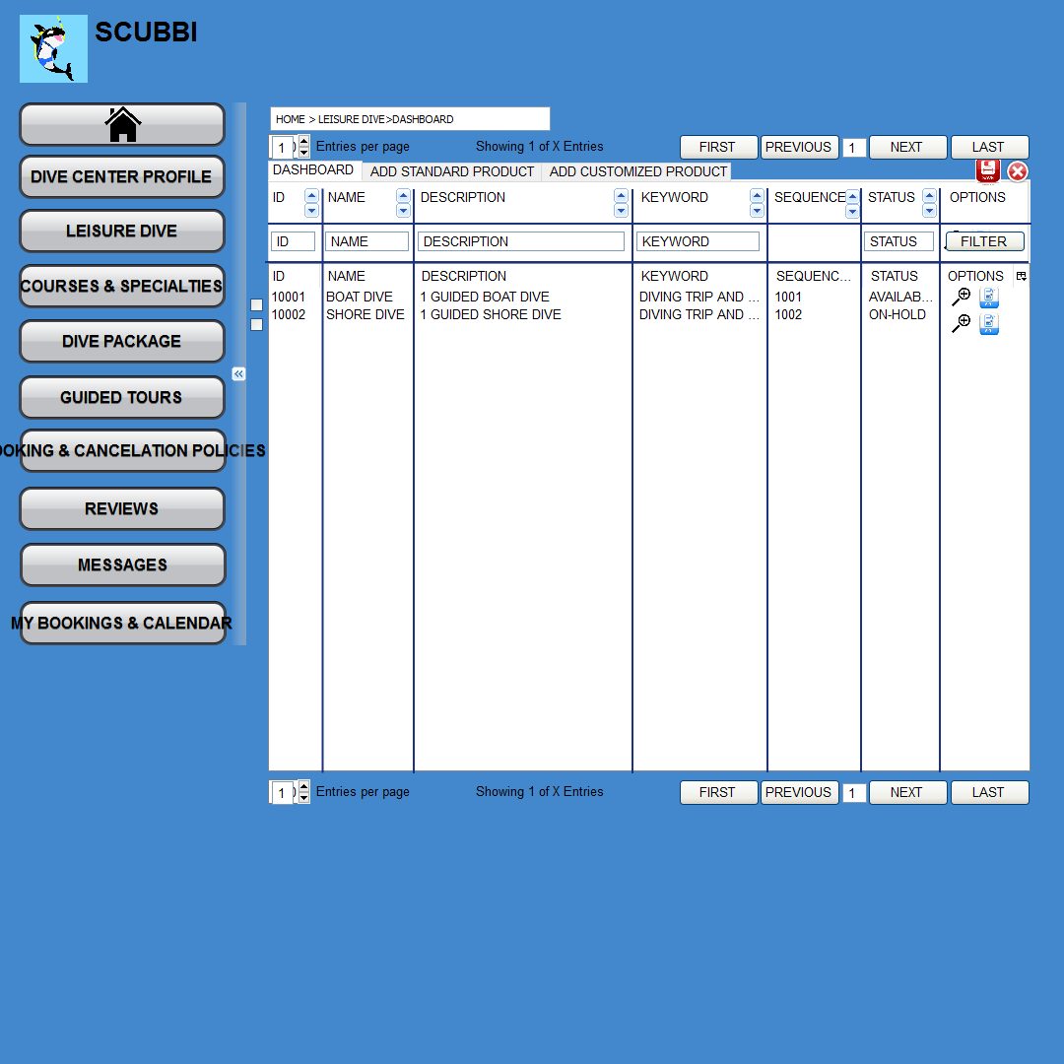

Added Sorting and Search Filter.

#### Business Rules

|  |  |  |  |  |  |
| --- | --- | --- | --- | --- | --- |
| **Field Name** | **Description** | **Data Type** | **Mandatory** | **Format** | **Data Source** |
|  |  |  |  |  |  |
|  |  | | | | |
|  |  |  |  |  |  |

### Add Standard Product

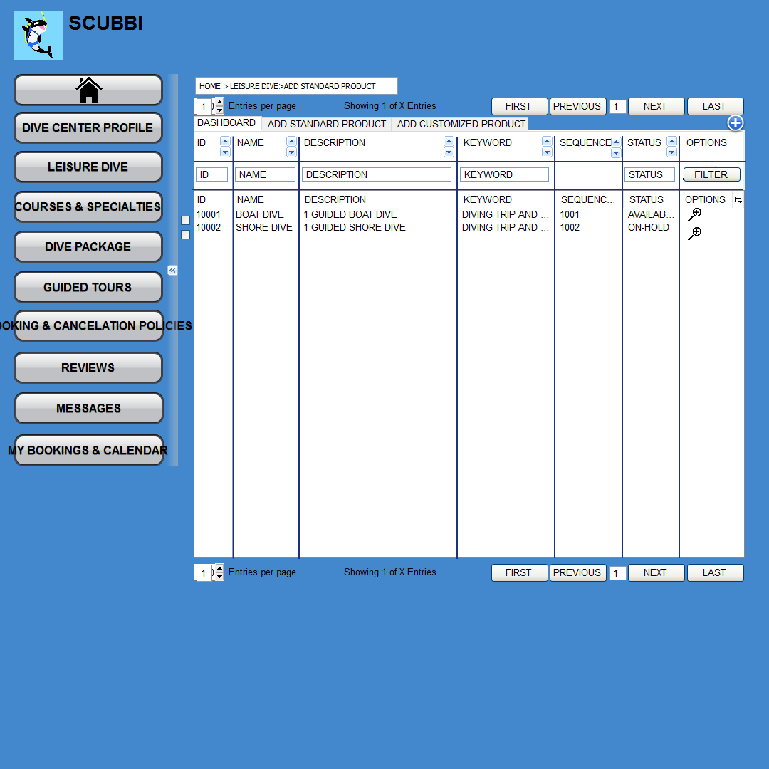

#### Business Rules

|  |  |  |  |  |  |
| --- | --- | --- | --- | --- | --- |
| **Field Name** | **Description** | **Data Type** | **Mandatory** | **Format** | **Data Source** |
|  |  |  |  |  |  |
|  |  | | | | |
|  |  |  |  |  |  |

### Add Customized Product

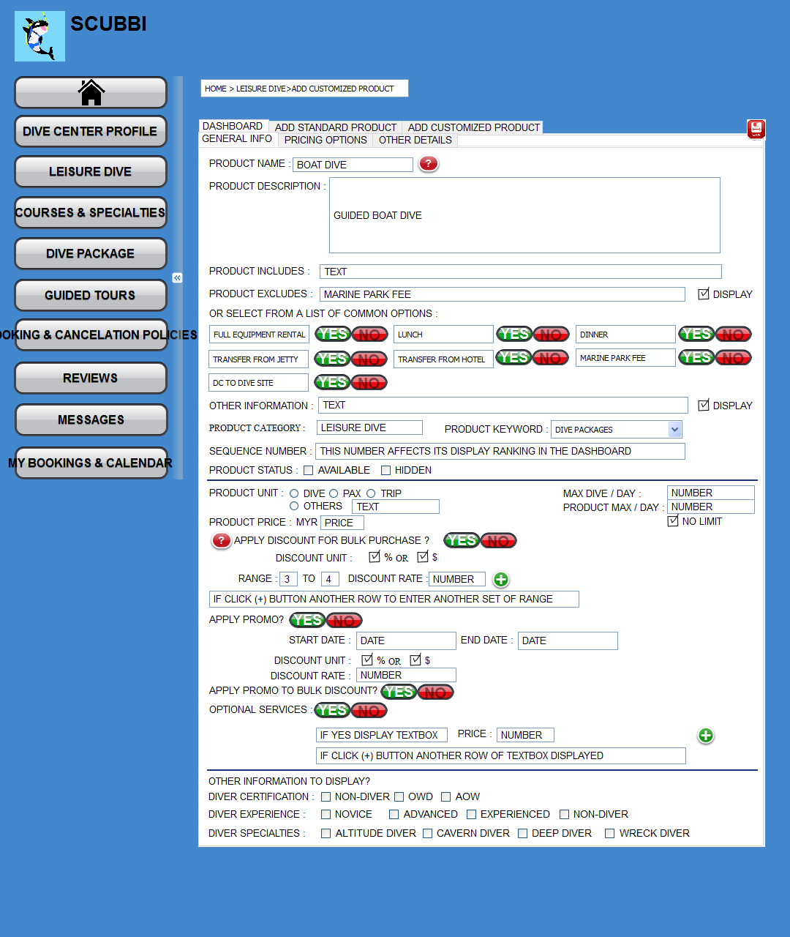

Added No limit option.

Mouse over Tool Tip. Applies to all text labels.

#### Business Rules

|  |  |  |  |  |  |
| --- | --- | --- | --- | --- | --- |
| **Field Name** | **Description** | **Data Type** | **Mandatory** | **Format** | **Data Source** |
|  |  |  |  |  |  |
|  |  | | | | |
|  |  |  |  |  |  |

## Courses & Specialties

### Courses & Specialties Dashboard

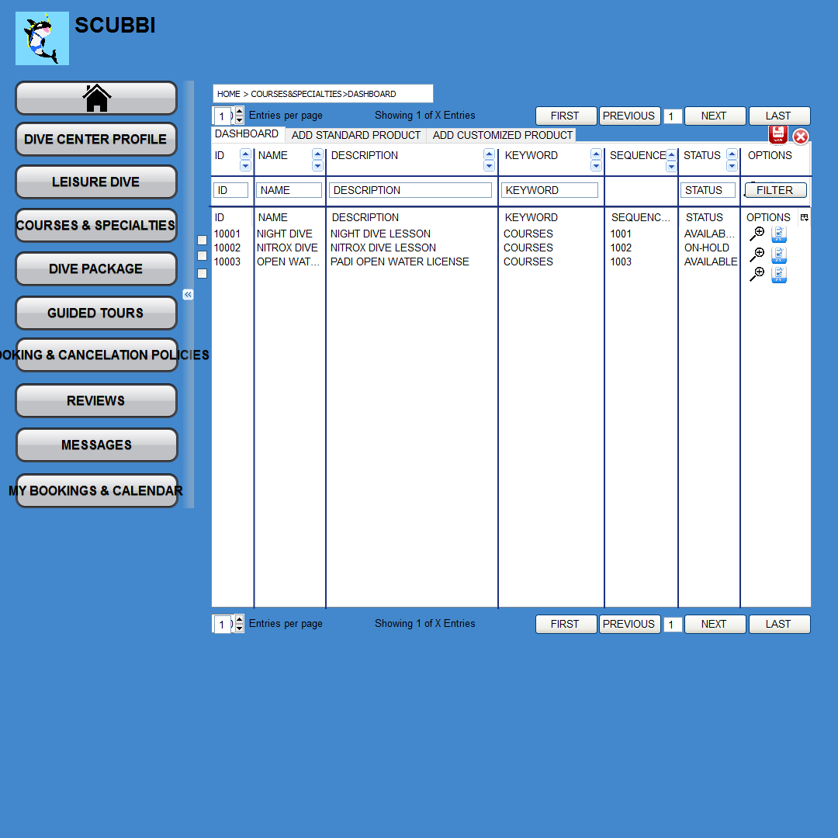

#### Business Rules

|  |  |  |  |  |  |
| --- | --- | --- | --- | --- | --- |
| **Field Name** | **Description** | **Data Type** | **Mandatory** | **Format** | **Data Source** |
|  |  |  |  |  |  |
|  |  | | | | |
|  |  |  |  |  |  |

### Add Standard Product

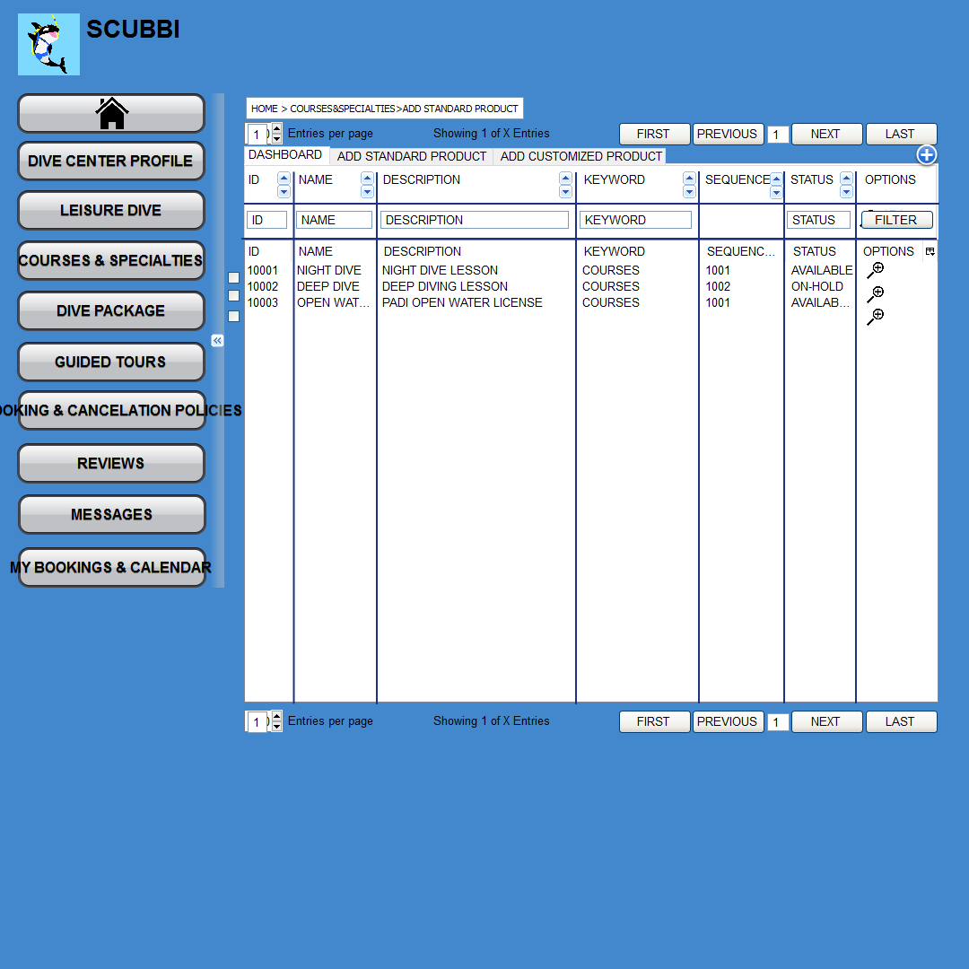

#### Business Rules

|  |  |  |  |  |  |
| --- | --- | --- | --- | --- | --- |
| **Field Name** | **Description** | **Data Type** | **Mandatory** | **Format** | **Data Source** |
|  |  |  |  |  |  |
|  |  | | | | |
|  |  |  |  |  |  |

### Add Customized Product

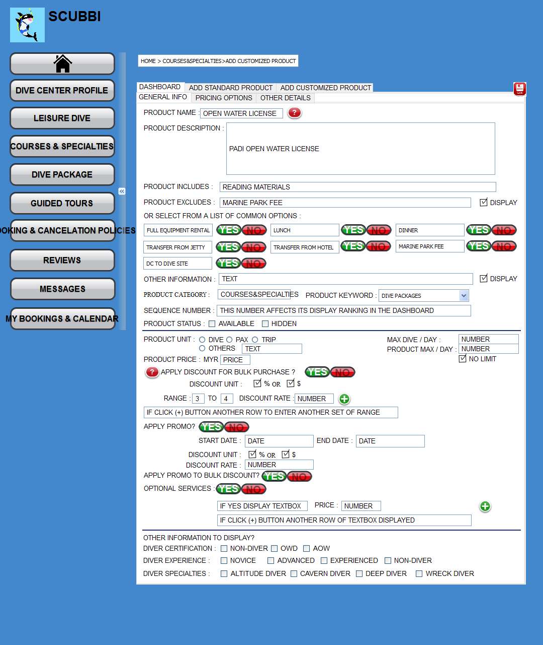

Added No limit option.

#### Business Rules

|  |  |  |  |  |  |
| --- | --- | --- | --- | --- | --- |
| **Field Name** | **Description** | **Data Type** | **Mandatory** | **Format** | **Data Source** |
|  |  |  |  |  |  |
|  |  | | | | |
|  |  |  |  |  |  |

## Dive Package

### Dive Package Dashboard

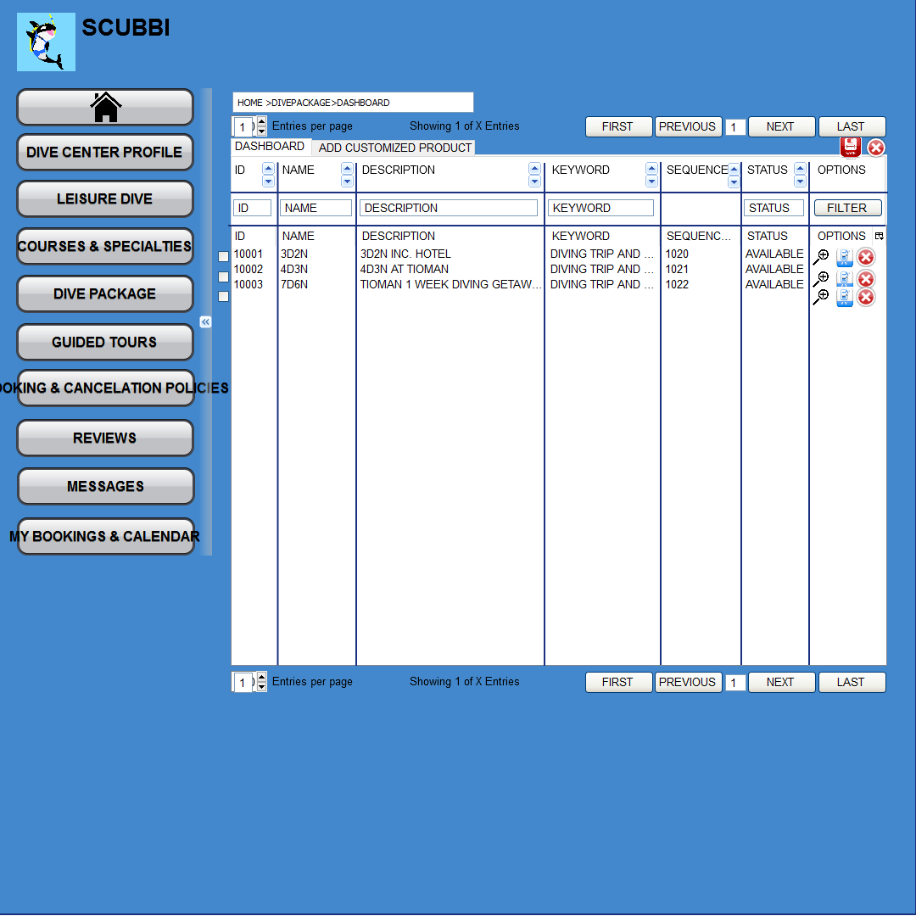

#### Business Rules

|  |  |  |  |  |  |
| --- | --- | --- | --- | --- | --- |
| **Field Name** | **Description** | **Data Type** | **Mandatory** | **Format** | **Data Source** |
|  |  |  |  |  |  |
|  |  | | | | |
|  |  |  |  |  |  |

### Add Customized Product

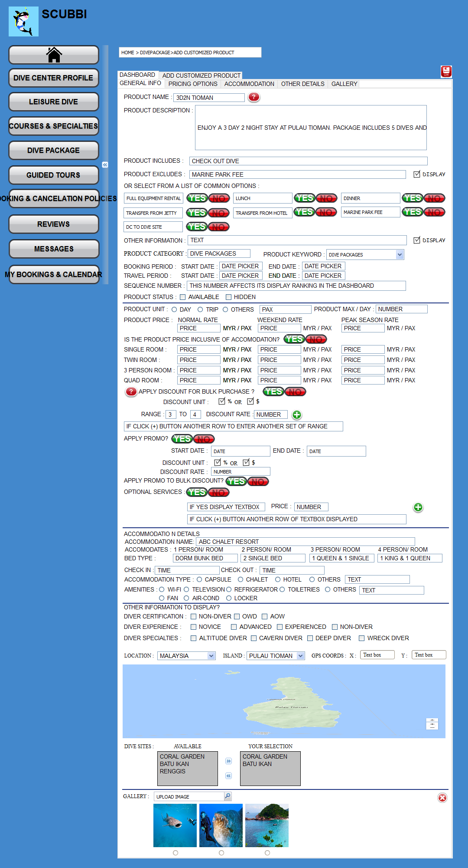

Refine and Modify Input Fields and Options.

#### Business Rules

|  |  |  |  |  |  |
| --- | --- | --- | --- | --- | --- |
| **Field Name** | **Description** | **Data Type** | **Mandatory** | **Format** | **Data Source** |
|  |  |  |  |  |  |
|  |  | | | | |
|  |  |  |  |  |  |

## Guided Tours

### Guided Tours Dashboard

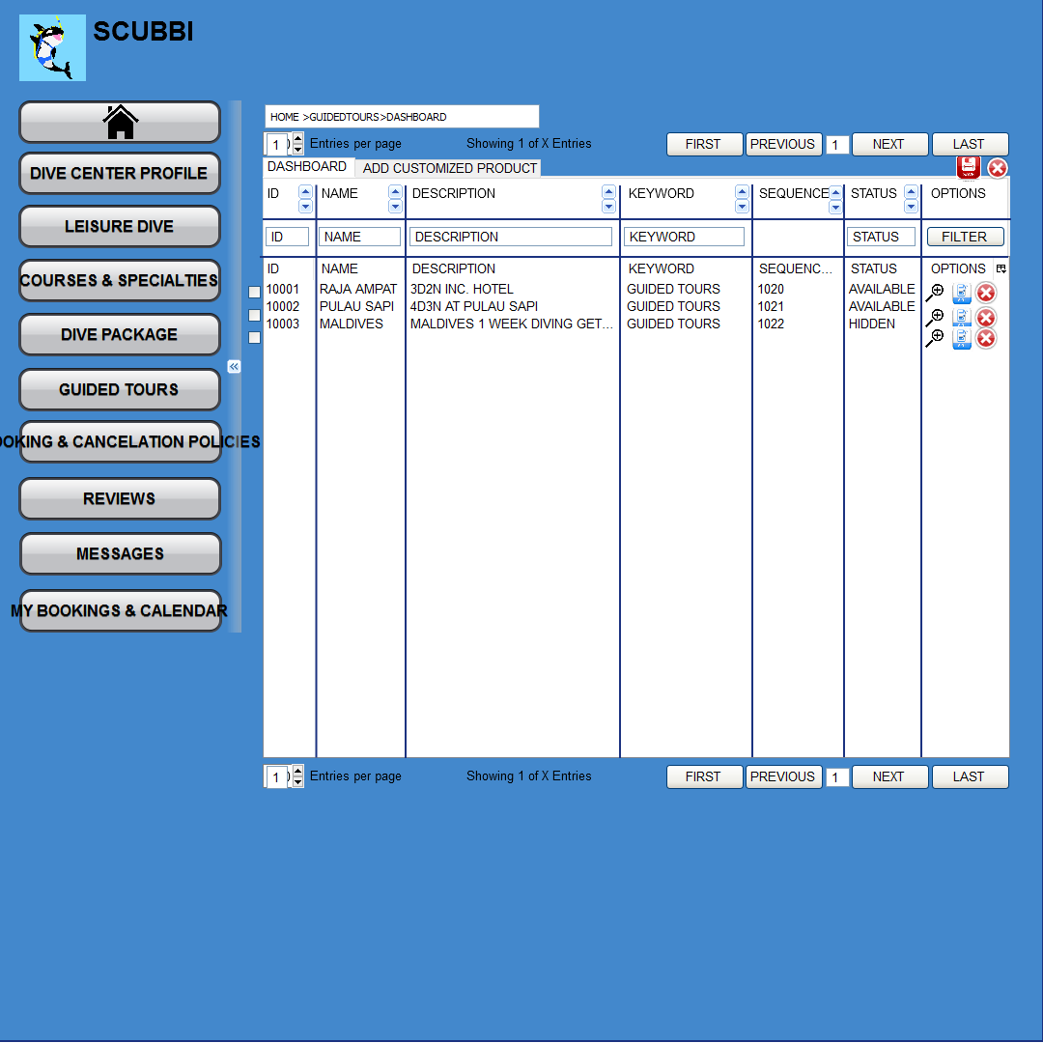

#### Business Rules

|  |  |  |  |  |  |
| --- | --- | --- | --- | --- | --- |
| **Field Name** | **Description** | **Data Type** | **Mandatory** | **Format** | **Data Source** |
|  |  |  |  |  |  |
|  |  | | | | |
|  |  |  |  |  |  |

### Add Customized Product

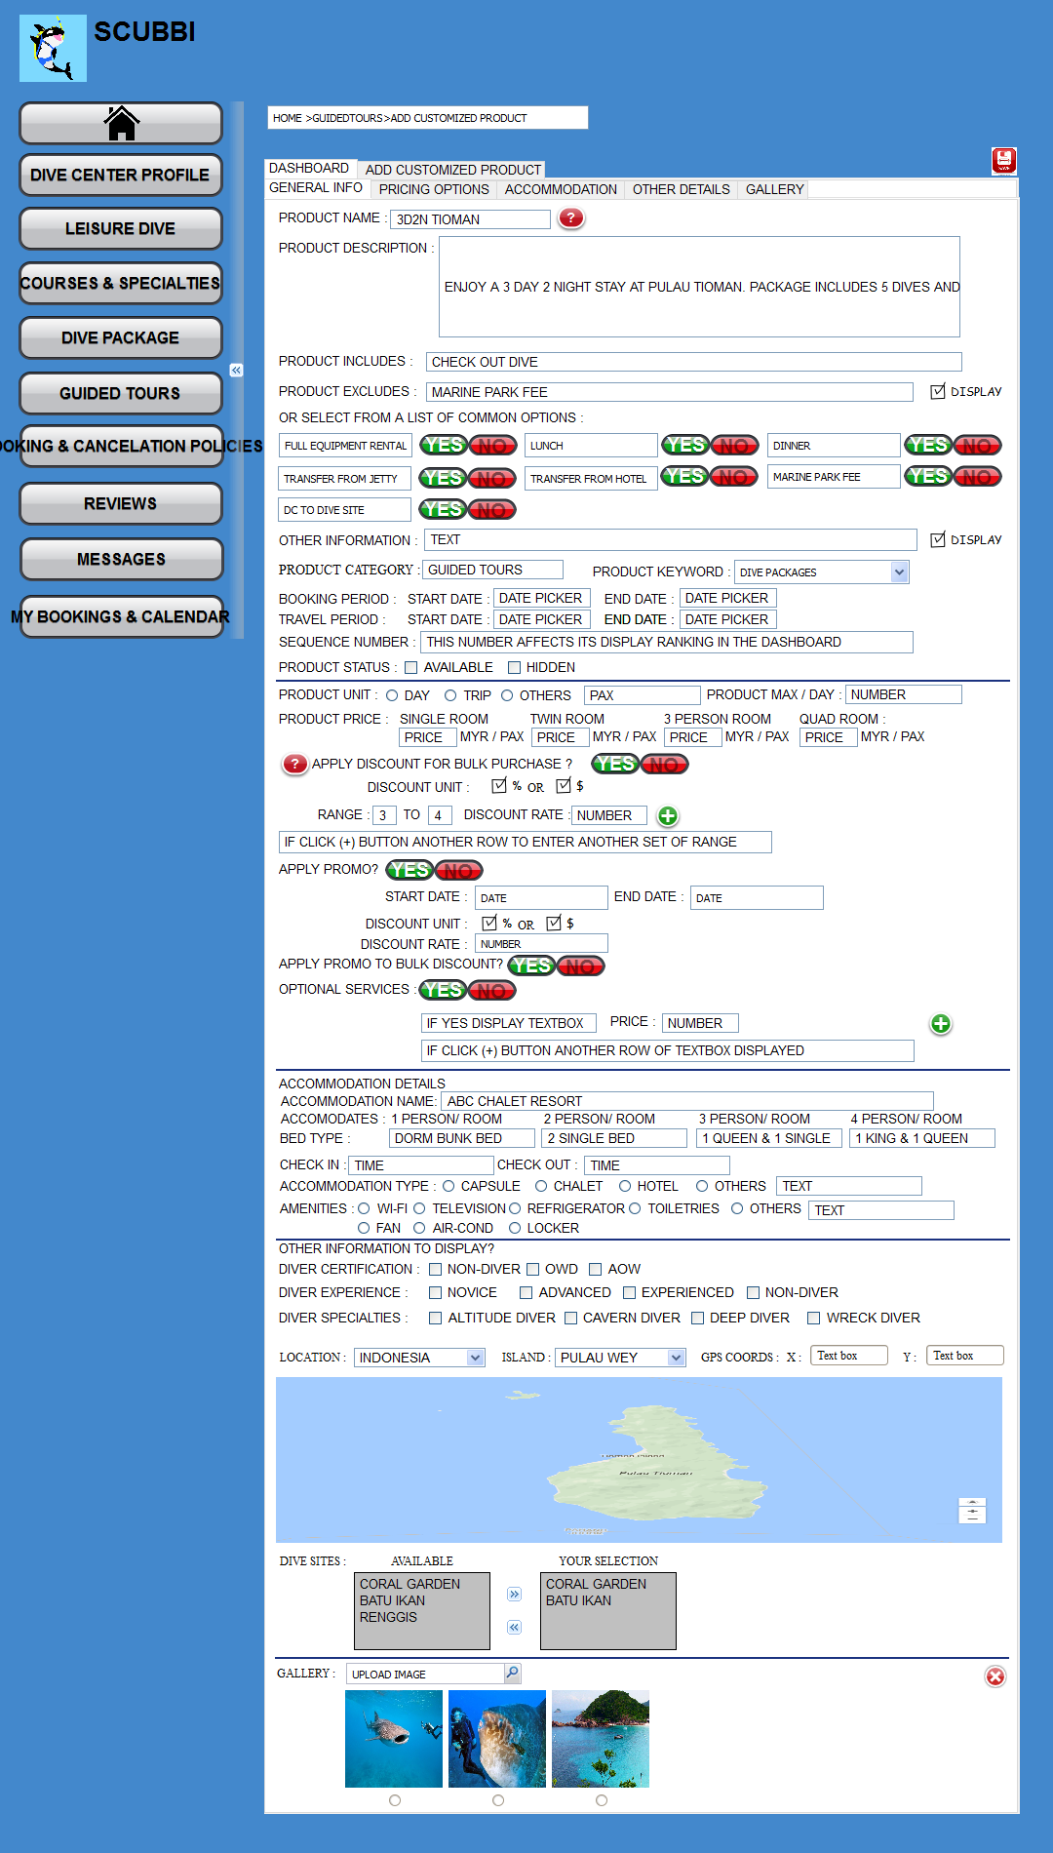

#### Business Rules

|  |  |  |  |  |  |
| --- | --- | --- | --- | --- | --- |
| **Field Name** | **Description** | **Data Type** | **Mandatory** | **Format** | **Data Source** |
|  |  |  |  |  |  |
|  |  | | | | |
|  |  |  |  |  |  |

## Booking & Cancellation Policies *Newly Added

### Booking & Cancellation Dashboard

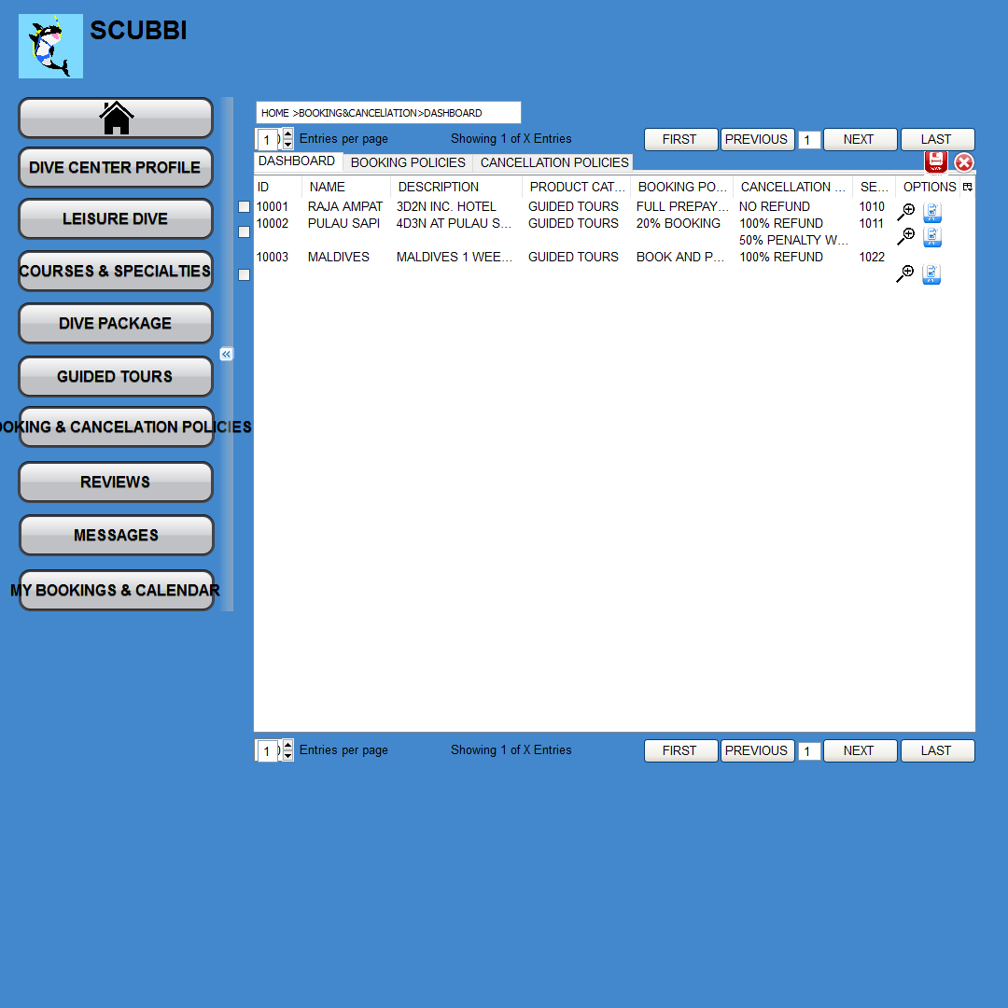

#### Business Rules

|  |  |  |  |  |  |
| --- | --- | --- | --- | --- | --- |
| **Field Name** | **Description** | **Data Type** | **Mandatory** | **Format** | **Data Source** |
|  |  |  |  |  |  |
|  |  | | | | |
|  |  |  |  |  |  |

#### Edit Policy

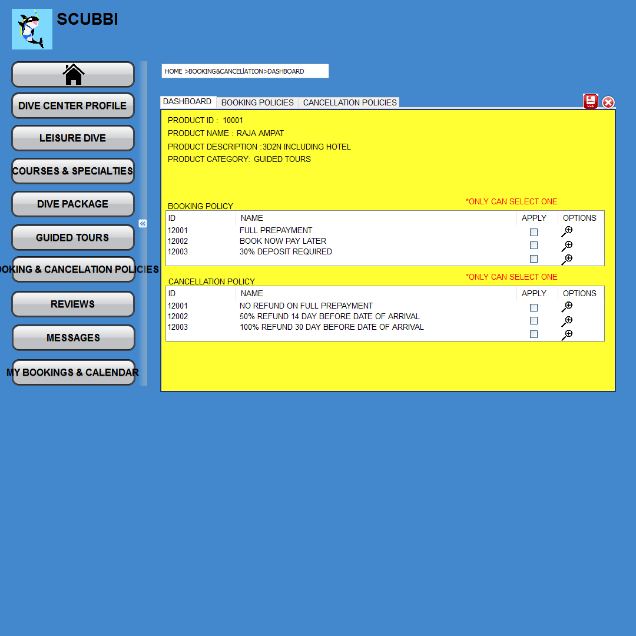

##### Business Rules

|  |  |  |  |  |  |
| --- | --- | --- | --- | --- | --- |
| **Field Name** | **Description** | **Data Type** | **Mandatory** | **Format** | **Data Source** |
|  |  |  |  |  |  |
|  |  | | | | |
|  |  |  |  |  |  |

### Booking Policy Tab

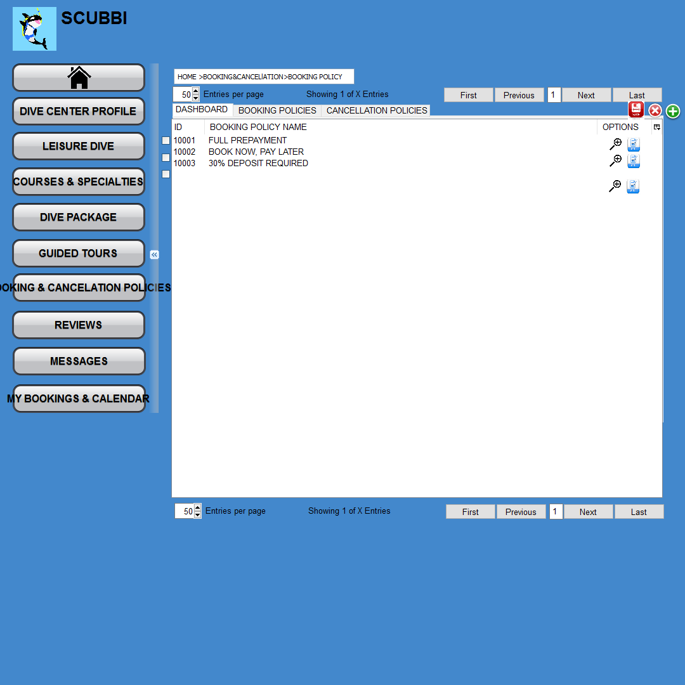

#### Business Rules

|  |  |  |  |  |  |
| --- | --- | --- | --- | --- | --- |
| **Field Name** | **Description** | **Data Type** | **Mandatory** | **Format** | **Data Source** |
|  |  |  |  |  |  |
|  |  | | | | |
|  |  |  |  |  |  |

#### Add Policy

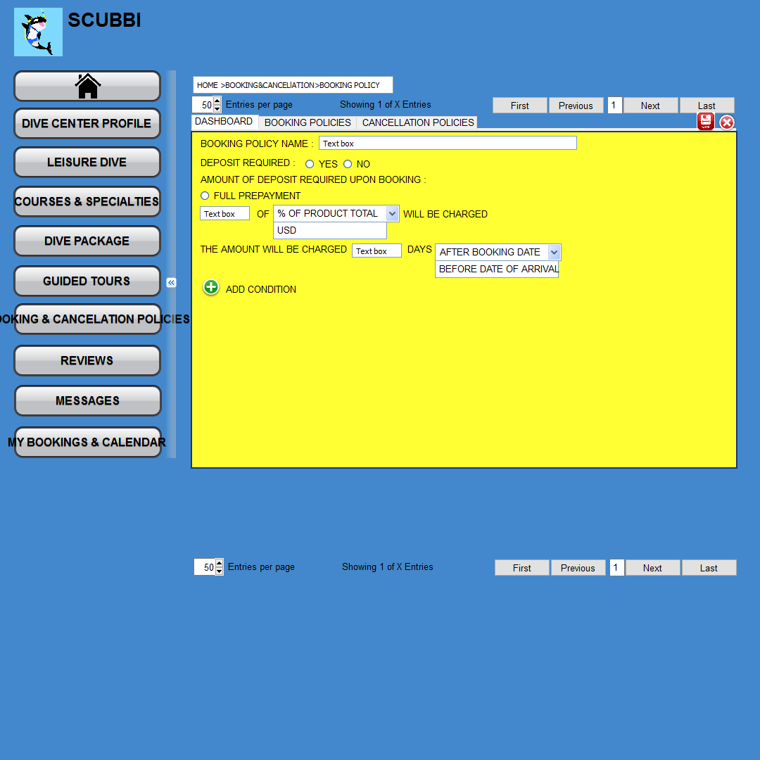

##### Business Rules

|  |  |  |  |  |  |
| --- | --- | --- | --- | --- | --- |
| **Field Name** | **Description** | **Data Type** | **Mandatory** | **Format** | **Data Source** |
|  |  |  |  |  |  |
|  |  | | | | |
|  |  |  |  |  |  |

### Cancellation Policy Tab

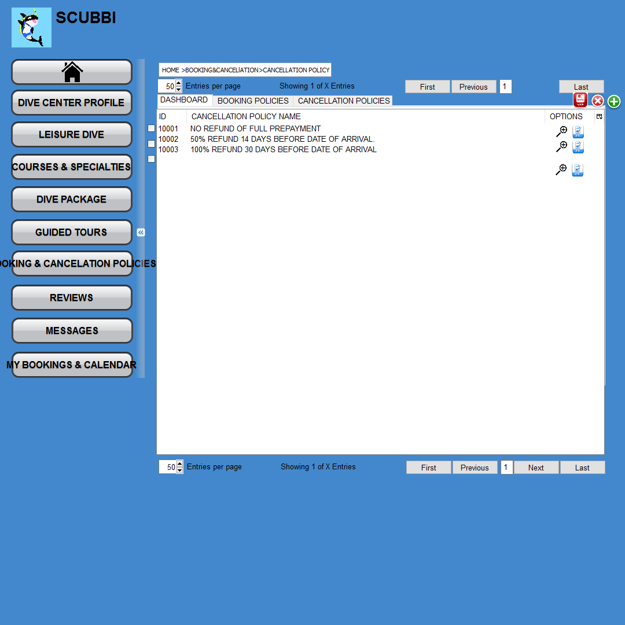

#### Business Rules

|  |  |  |  |  |  |
| --- | --- | --- | --- | --- | --- |
| **Field Name** | **Description** | **Data Type** | **Mandatory** | **Format** | **Data Source** |
|  |  |  |  |  |  |
|  |  | | | | |
|  |  |  |  |  |  |

#### Add Policy

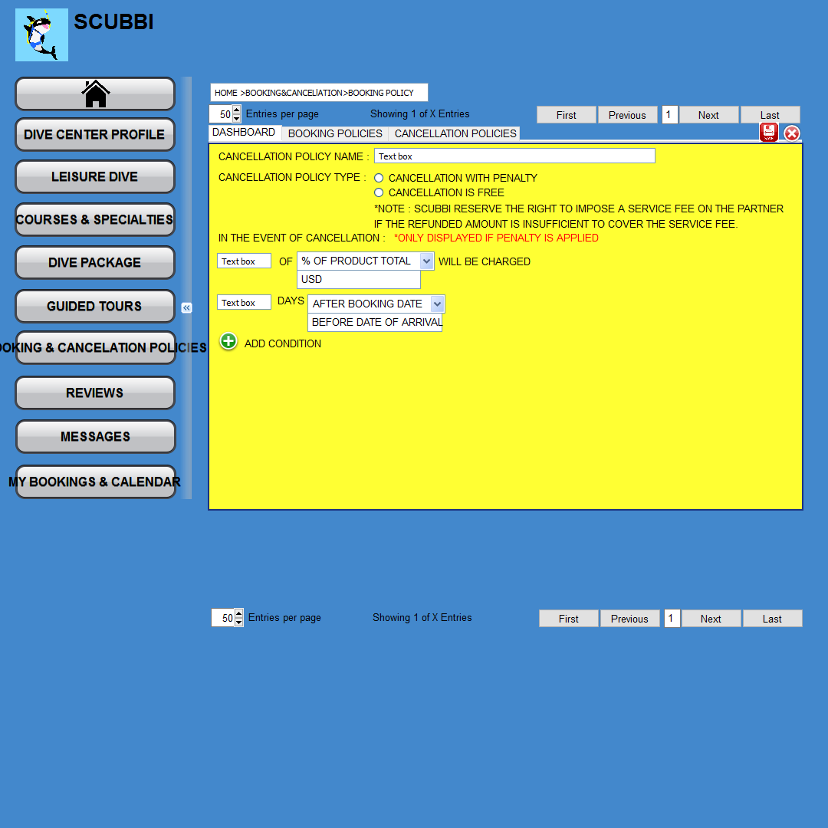

##### Business Rules

|  |  |  |  |  |  |
| --- | --- | --- | --- | --- | --- |
| **Field Name** | **Description** | **Data Type** | **Mandatory** | **Format** | **Data Source** |
|  |  |  |  |  |  |
|  |  | | | | |
|  |  |  |  |  |  |

## Reviews *Newly Added

### Reviews Dashboard

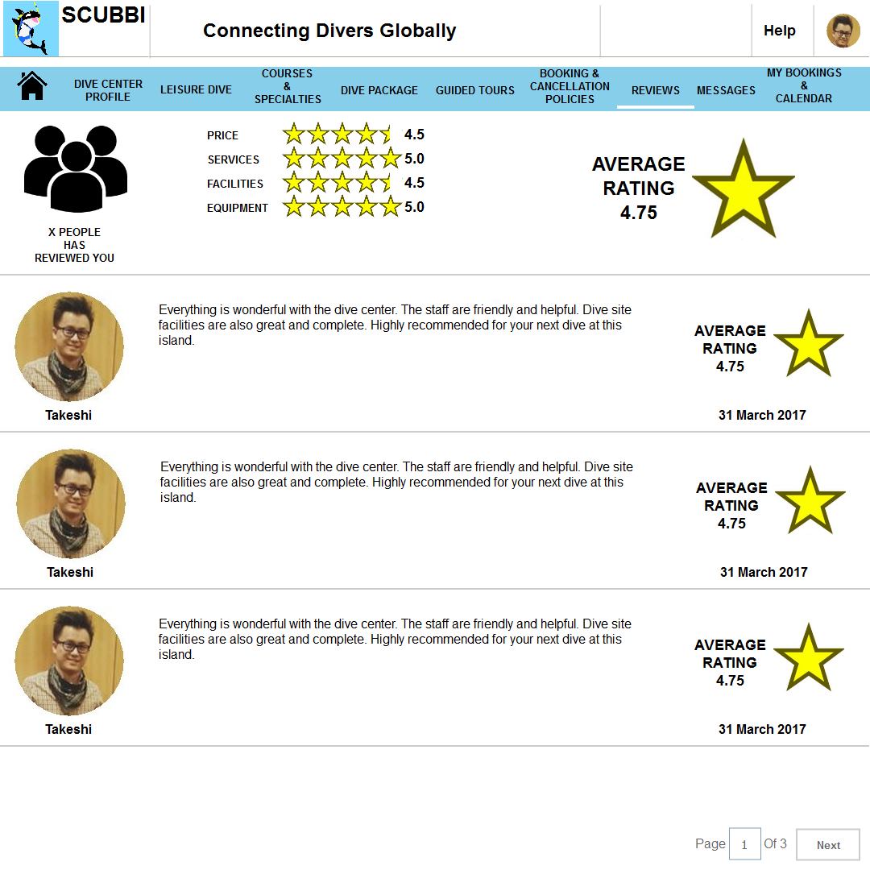

#### Business Rules

|  |  |  |  |  |  |
| --- | --- | --- | --- | --- | --- |
| **Field Name** | **Description** | **Data Type** | **Mandatory** | **Format** | **Data Source** |
|  |  |  |  |  |  |
|  |  | | | | |
|  |  |  |  |  |  |

## Messages *Newly Added

### My Bookings & Calendar Dashboard

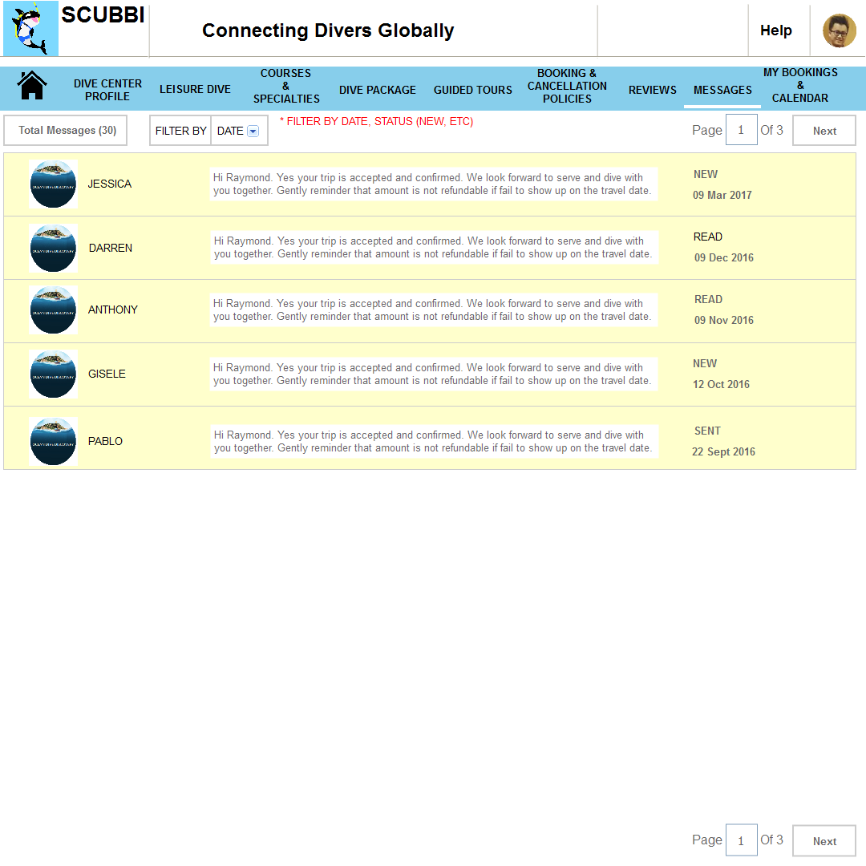

#### Business Rules

|  |  |  |  |  |  |
| --- | --- | --- | --- | --- | --- |
| **Field Name** | **Description** | **Data Type** | **Mandatory** | **Format** | **Data Source** |
|  |  |  |  |  |  |
|  |  | | | | |
|  |  |  |  |  |  |

## My Bookings & Calendar *Newly Added

### My Bookings & Calendar Dashboard

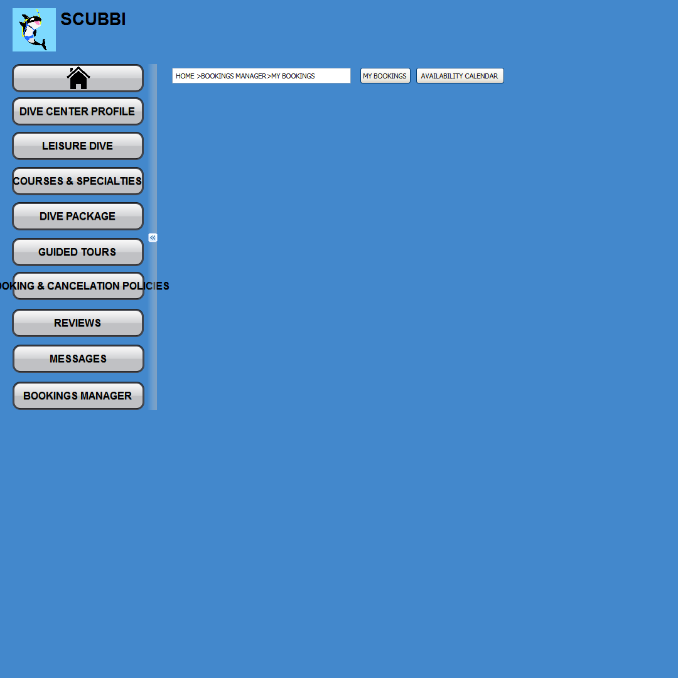

#### Business Rules

|  |  |  |  |  |  |
| --- | --- | --- | --- | --- | --- |
| **Field Name** | **Description** | **Data Type** | **Mandatory** | **Format** | **Data Source** |
|  |  |  |  |  |  |
|  |  | | | | |
|  |  |  |  |  |  |

### My Bookings Tab

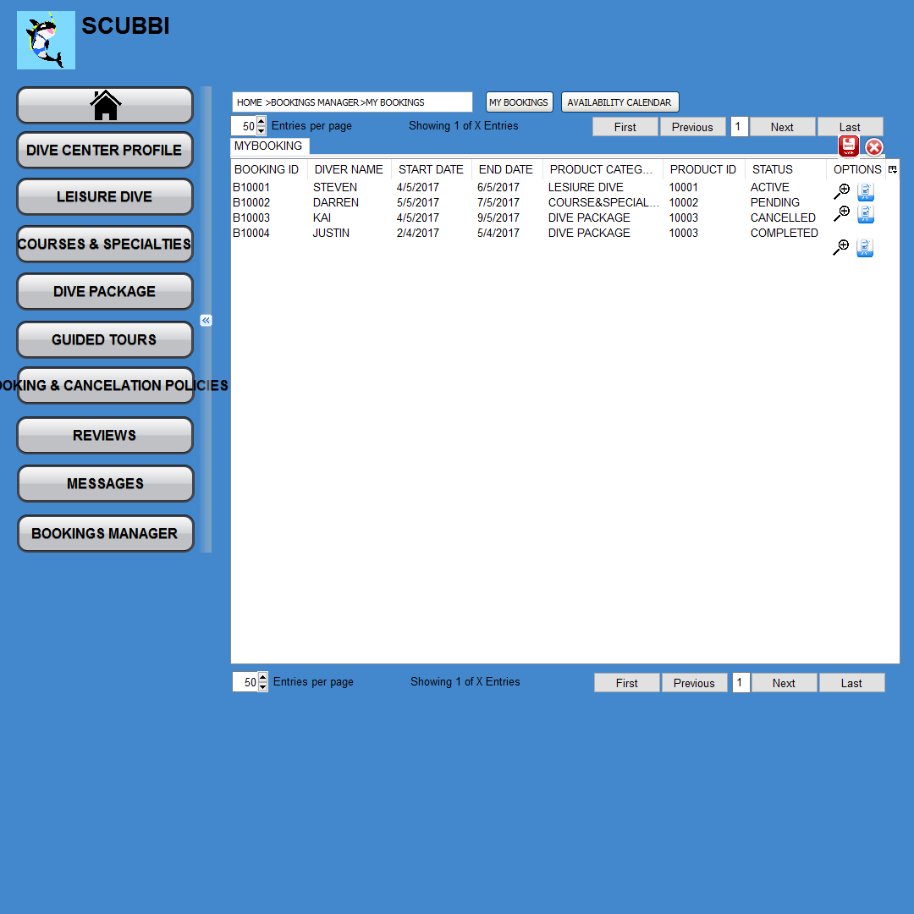

#### Business Rules

|  |  |  |  |  |  |
| --- | --- | --- | --- | --- | --- |
| **Field Name** | **Description** | **Data Type** | **Mandatory** | **Format** | **Data Source** |
|  |  |  |  |  |  |
|  |  | | | | |
|  |  |  |  |  |  |

### Availability Calendar Tab

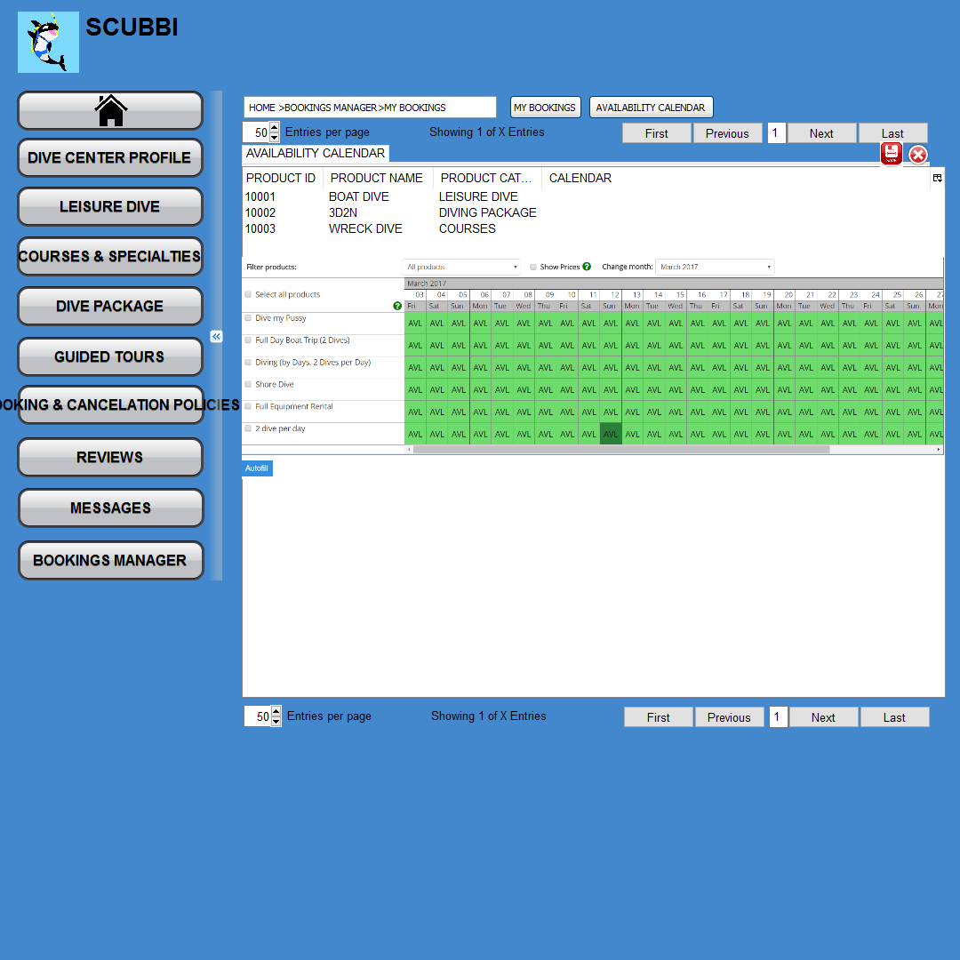

#### Business Rules

|  |  |  |  |  |  |
| --- | --- | --- | --- | --- | --- |
| **Field Name** | **Description** | **Data Type** | **Mandatory** | **Format** | **Data Source** |
|  |  |  |  |  |  |
|  |  | | | | |
|  |  |  |  |  |  |

## Become a Partner *Newly Added

Upon clicking on the Customer Module > Landing Page > Become a Partner link, this will re-direct to

Dive Center Registration Page as mentioned below:

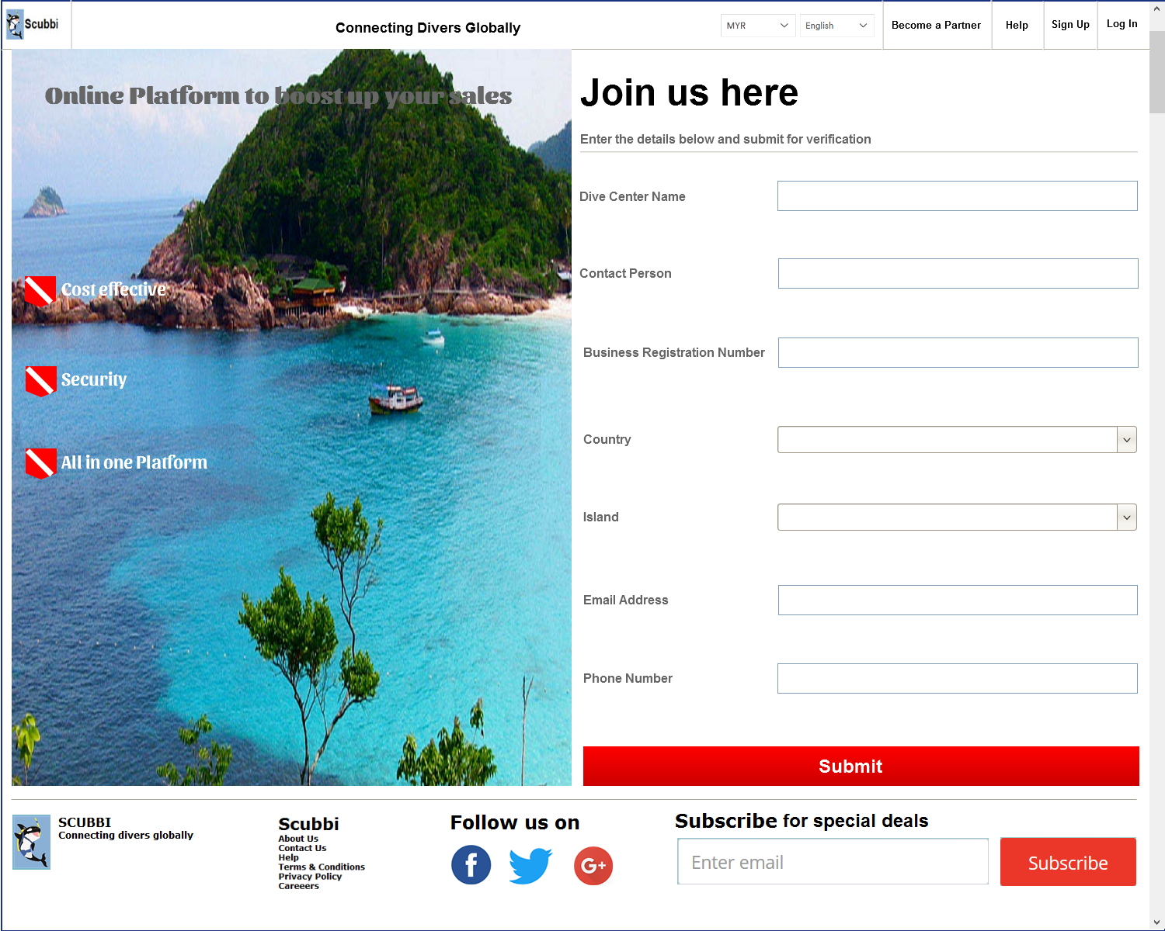

**Screenshot 1.11.0.1 Dive Center Registration Page**

### Business Rules

| **Field Name** | **Description** | **Data Type** | **Mandatory** | **Format** | **Data Source** |
| --- | --- | --- | --- | --- | --- |
| **Dive Center Name** | Name of Dive Center | Alphanumeric | Y | 200 | N/A |
| Business Rules | N/A | | | | |
| **Contact Person** | PIC name of the Dive Center | Alphanumeric | Y | 200 | N/A |
| Business Rules | N/A | | | | |
| **Business Registration Number** | Dive Center business registration number. | Alphanumeric | Y | 200 | N/A |
| Business Rules | N/A | | | | |
| **Country** | Dive Center Country Name | Drop down list | Y | N/A | N/A |
| Business Rules | Upon selecting the country from the drop down list, will determine island name render in the Island drop down list. | | | | |
| **Island** | Dive Center Island Name | Drop down list | Y | N/A | N/A |
| Business Rules | Drop list value is render based on the Country selection. | | | | |
| **Email Address** | Dive Center Email Address | Text box | Y | N/A | N/A |
| Business Rules | N/A | | | | |
| **Phone Number** | Dive Center Phone Number | Text box | Y | N/A | N/A |
| Business Rules | N/A | | | | |
| **Submit** | Dive Center clicks on the button to submit information to SCUBBI Service team. | button | N/A | N/A | N/A |
| Business Rules | * Upon clicking on the Submit button, information entered by Dive Center will be sending to SCUBBI Service Team for verification purpose. In addition, an email notification will also send to SCUBBI Service Team email address. * If Dive Center click on the Submit button without enter any fields, system to prompt “[Field Name] is a mandatory field.” error message.   Note: [Field Name] can be any field name above. For example, “Dive Center Name is a mandatory field.” | | | | |

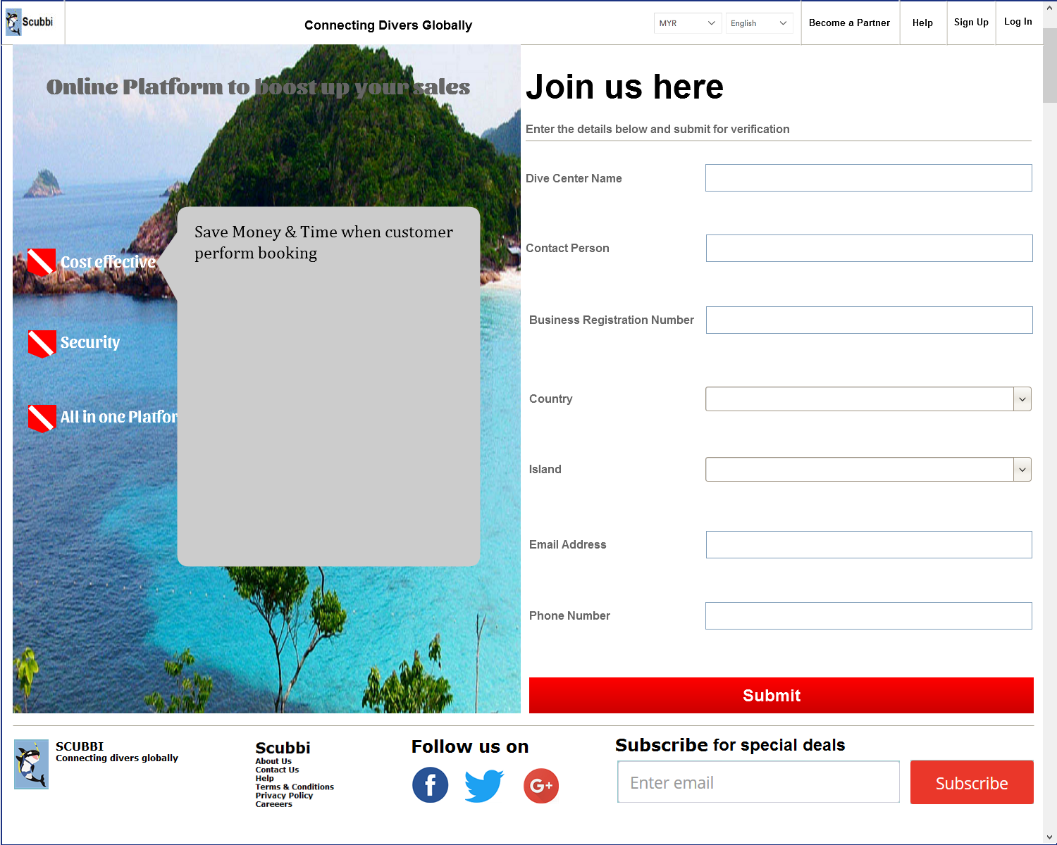

**Screenshot 1.11.0.2 Dive Center Registration Page**

### Business Rules

|  |  |  |  |  |  |
| --- | --- | --- | --- | --- | --- |
| **Field Name** | **Description** | **Data Type** | **Mandatory** | **Format** | **Data Source** |
| **Cost Effective** | Upon hover over the mouse to the icon and words, display details information about Cost Effective. | Link | N/A | N/A | N/A |
| Business Rules | Text inside the details screen can be configure under SCUBBI Admin module. | | | | |
| **Security** | Upon hover over the mouse to the icon and words, display details information about Security. | Link | N/A | N/A | N/A |
| Business Rules | Text inside the details screen can be configure under SCUBBI Admin module. | | | | |
| **All in one Platform** | Upon hover over the mouse to the icon and words, display details information about All in one Platform. | Link | N/A | N/A | N/A |
| Business Rules | Text inside the details screen can be configure under SCUBBI Admin module. | | | | |

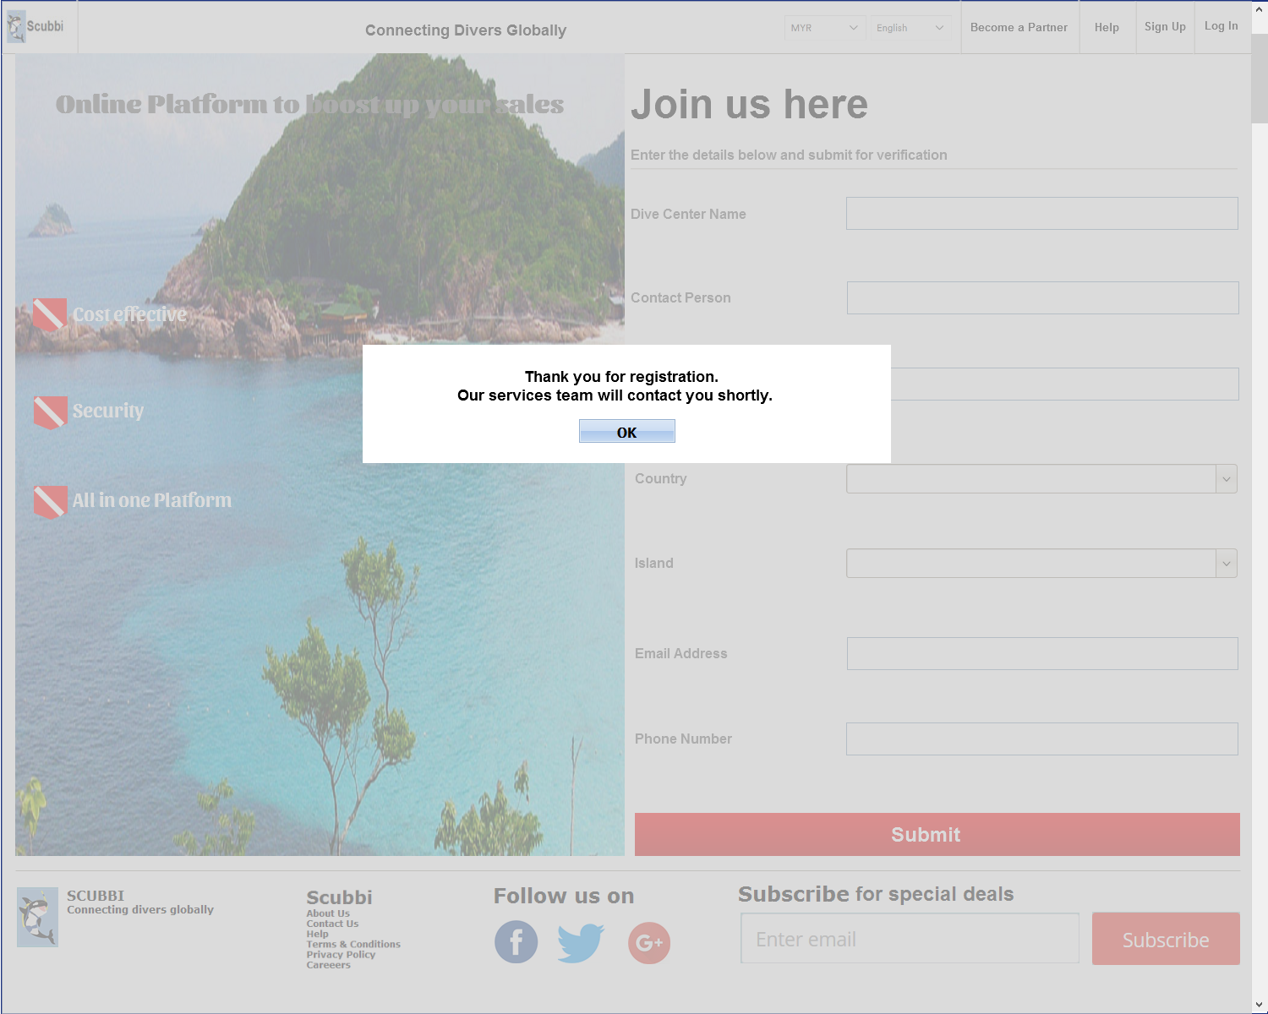

**Screenshot 1.11.0.2 Successful Registration**

### Business Rules

|  |  |  |  |  |  |
| --- | --- | --- | --- | --- | --- |
| **Field Name** | **Description** | **Data Type** | **Mandatory** | **Format** | **Data Source** |
| **Submit** | Submit button | button | N/A | N/A | N/A |
| Business Rules | After information sent to SCUBBI Service Team successfully, grey out the screen and pop up a screen with OK button. Upon clicking on the OK button, system to re-direct back to Landing Page automatically. | | | | |

# Appendices

Diving app and website feature

**User features: buyers and dive centers**

Email log in – home page

Social log in –home page

App dashboard –after account log in

Activity feed –package and activity calendar update

Rating sys –both dive center and diver rating on each party

Geolocation –dive center location pinpoint inside google map

Custom user interface –both party

User profile -- both party

Accept payment – dive center

Sync across all device – sync with user device for both party

Shopping cart –package that diver books

Search bar –search by location, date available, dive center name

Calender integration –link with google calendar for both party

Social sharing –fb, linkin, twitter etc

3rd parties API integration-- pending*

Push notification - location marketing

Menu/ordering – user purchase dive package online

Contact info –both party

Reservation –booking for trip

Event listing –dive center package/event/promotion list

Email and mailing listing –divers

Ad serve – internal SEO on dive platform

Messaging –both party*

Maps – dive center location

Sms integration –payment reminder *

**Admin features:**

Approval and moderation

Reporting -- Daily, weekly and monthly

Content management system

Payment administration

User administration

Ticketing system-- pending*

Customer loyalty program system

**User Profiles Page**

User Portfolio (Customer Photo, Dive Card, Address & Email)

Upcoming Dives

Historical Dives

PS: For item with * is considering those feature that still pending.